Key Store Manager Design Notes

Owner: | Jo Stichbury
Last revised: | 3rd September 2002
Revision: | 0.04
Status: | DRAFT
Contributors: | Leon Clarke
Key Reviewers: | Leon Clarke, William Bamberg
Distribution
Approved By: |  | Approval Ref.:

Contents
1. Introduction 3
1.1 Purpose and scope 3
1.2 References 3
1.3 Open Issues 3
1.4 Glossary 3
1.5 Document History 3
2. Overview 3
2.1 Client Side access to Key Store 4
2.2 Server Side access to filecertstore 4
2.3 Appendix 6
2.3.1 MKeyStore.h 6
2.3.2 MCTKeyStore.h 6
2.3.3 MCTKeyStoreManager.h 9

Introduction
Draft document for describing the current state of planned design of the key store as part of Jetstream Security project GT140 . The development is ongoing so the content of this document is subject to change and should not be taken as final.

Purpose and scope
To describe the APIs implemented by the keystore manager.

References
- Key Store Architectural Analysis
- GT00140 Jet Stream Project Task: Execution of Requirement 325.1.2.1 “Modify filecertstore to be client server”

Open Issues

Glossary
The following technical terms and abbreviations are used within this document.

Document History
Date | Version | Status | Description
19/06/2002 | 0.01 | Draft | Quick description of the current state of play of Key Store design
14/08/2002 | 0.02 | Draft | Updated to reflect latest stage of ongoing code development
16/08/2002 | 0.03 | Draft | Update Rose diagrams to reflect current code development
03/09/2002 | 0.04 | Draft | Updated appendices

Overview
The CTFramework interfaces to access the keystore are described as an appendix to this document (from header files). These interfaces should be used by components wishing to use the keystore.
The following sections describe the internal design of the keystore and are not relevant except as a guide to the security team members implementing the keystore itself.

Client Side access to Key Store
Most of the client-side classes implementing the filecertstore are generic and will be reusable (see GT00140 Jet Stream Project Task: Execution of Requirement 325.1.2.1 “Modify filecertstore to be client server” for further details).
The only extra functionality to add will implement the client side representation of MCTKeyStore and MCTKeyStoreManager (directing requests to the server and performing appropriate client/server data marshalling).

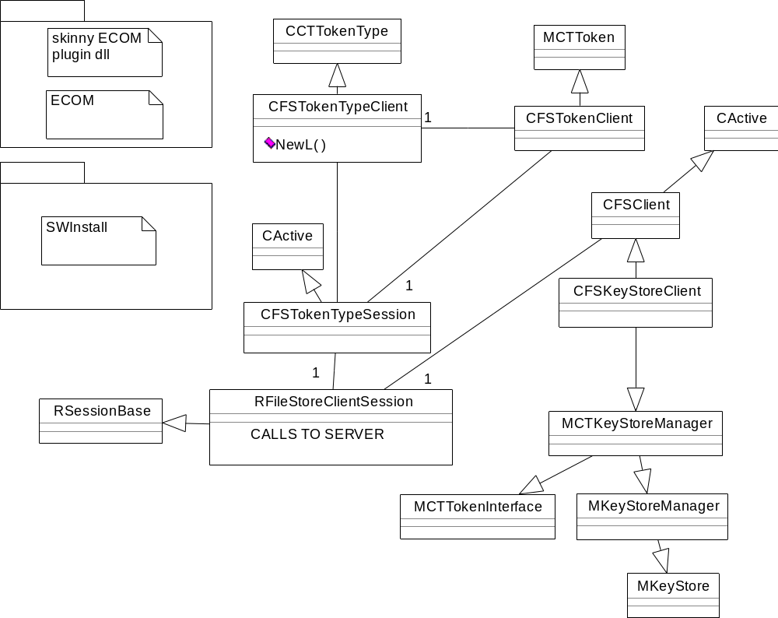

Server Side access to filecertstore
The key store will be implemented as a separate new token type and token to maintain separation between the certificate and key stores in the file store tokentype server. Most of the top level server can be reused without requiring much modification beyond adding checking for whether client requests should be directed to the keystore or certstore tokens.
The token interfaces will be split into two – for user and for owner actions. This enforces the owner/user split without the client making calls into the server that are rejected because the client does not fulfil the correct role for a call.
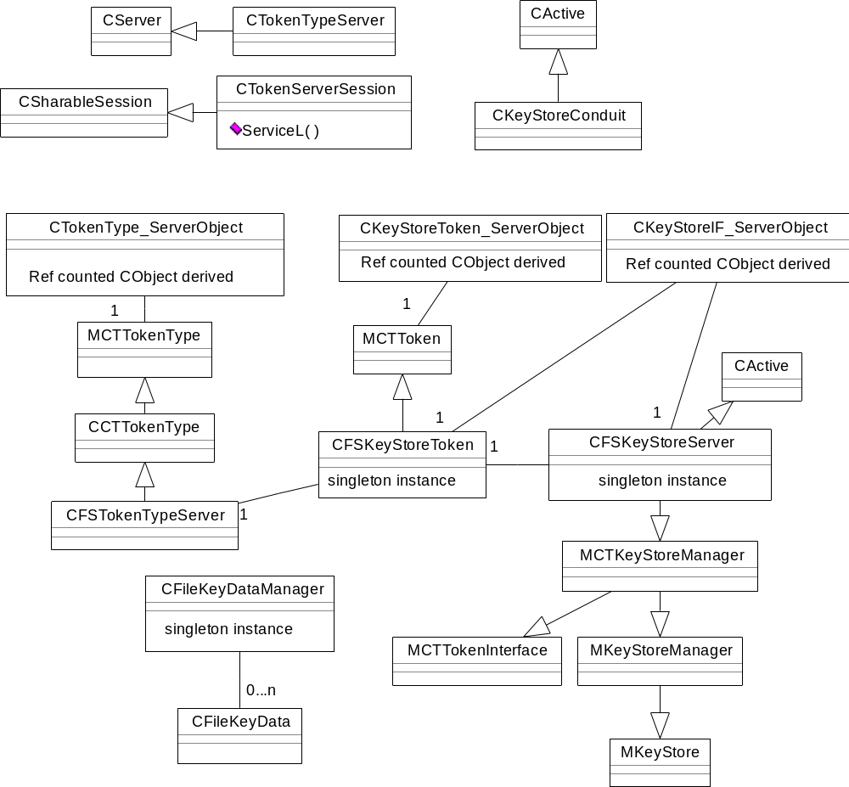

Appendix

MKeyStore.h
// Copyright (c) Symbian Ltd 2001

#ifndef __MKEYSTORE_H__
#define __MKEYSTORE_H__

#include <ct.h>

class CCTKeyInfo;
struct TCTKeyAttributeFilter;

/** @ingroup interfaces */
/** @{ */

/** A representation of a key store on a token. This lets the client
query the keys */
class MKeyStore
{
public:
///@name Listing keys */
///@{
/** List all the keys in the store that match the filter.
@param aKeys An array to which the returned keys are appended.
@param aFilter a filter controlling which keys are returned.
@param aStatus This will be completed with the final status code
*/
virtual void List(RMPointerArray<CCTKeyInfo>& aKeys,
const TCTKeyAttributeFilter& aFilter,
TRequestStatus& aStatus) = 0;
/** Cancel an ongoing List operation */
virtual void CancelList() = 0;
///@}

///@name Getting a key given a TCTTokenObjectHandle */
///@{
/** Retrieves a key given its handle.
@param aHandle The handle of the required key
@param aInfo The returned key info
@param aStatus Async request notification */
virtual void GetKeyInfo(TCTTokenObjectHandle aHandle, CCTKeyInfo*& aInfo,
TRequestStatus& aStatus) = 0;
/** Cancel an ongoing GetKeyInfo operation */
virtual void CancelGetKeyInfo() = 0;
///@}
};
///@}
#endif // __MKEYSTORE_H__

MCTKeyStore.h
// Copyright (c) Symbian Ltd 2001
#ifndef __MCTKEYSTORE_H__
#define __MCTKEYSTORE_H__
#include <securitydefs.h>
#include <mkeystore.h>
#include <s32file.h>
///@file
class MCTAuthenticationObject;
/** The UID of a key store interface */
const TInt KInterfaceKeyStore = 0x101F7334;

/** The type ID of CCTKeyInfo objects */
const TUid KKeyInfoUID = {0x101F5152};

// Defined below is MCTKeyStore, mixes in MCTTokenInterface with MKeyStore
class MCTKeyStore : public MCTTokenInterface, public MKeyStore
{
};

/** @ingroup interfaces */
/** @{ */
/** Information about a key, as returned by MCTKeyStore::List */
class CCTKeyInfo : protected CBase, public MCTTokenObject
{
public:
enum EKeyAlgorithm
{
EInvalidAlgorithm = 0,
ERSA = 1,
EDSA = 2,
EDH = 3
};

enum EKeyAccess
{
EInvalidAccess = 0x0,
EExtractable = 0x1,
ESensitive = 0x2
};
public:
/** Creates a CCTKeyInfo.
@param aID The SHA1 hash of the key
@param aUsage The usage of the key
@param aSize The size of the key in bytes
@param aProtector A protector object if the key is protected by a PIN.
This may be NULL if the protector is not known.
@param aLabel The label of the key
@param aToken The token the key is in
@param aHandle The object ID part of the object handle; an
integer that is unique amongst keys in this token.
*/
IMPORT_C static CCTKeyInfo* NewL(TKeyIdentifier aID, TKeyUsage aUsage,
TUint aSize, MCTAuthenticationObject* aProtector,
HBufC* aLabel, MCTToken& aToken, TInt aHandle,
TUid aOwner, const RArray<TUid>& aUsers,
EKeyAlgorithm aAlgorithm,
TBool aIsExportable,
EKeyAccess aAccessType);

/** Creates a new KeyInfo from a stream
@param aToken The token that the info is part of
@param aStream The stream to read the info from
*/
IMPORT_C static CCTKeyInfo* NewL(MCTToken& aToken, RReadStream& aStream);

/** Destructor */
~CCTKeyInfo();

/** The ID (SHA-1 hash) of the key */
inline TKeyIdentifier ID() const;
/** The key usage */
inline TKeyUsage Usage() const;
/** The size of the key */
inline TUint Size() const;
/** The PIN (or other authentication object) that protects the key.
NULL if not known */
inline MCTAuthenticationObject* Protector() const;

/** The owner of a key */
inline TUid Owner();
/** The users of a key */
inline const RArray<TUid>& Users();

/** The key algorithm*/
inline EKeyAlgorithm Algorithm() const {return (iAlgorithm);};

/** The key's exportability */
inline TBool IsExportable() const {return (iIsExportable);};

/** The key access type*/
inline EKeyAccess AccessType() const {return (iAccessType);};

inline operator TCTTokenObjectHandle() const;
public: // Allow some data to be set...
IMPORT_C void SetHandle(TInt);
IMPORT_C void SetIdentifier(TKeyIdentifier);
public: // To simplify streaming
IMPORT_C void ExternalizeL(RWriteStream& aStream) const;
IMPORT_C void InternalizeL(RReadStream& aStream);

public: ///@name from MCTTokenObject
///@{
/** The label of the key */
virtual const TDesC& Label() const;
/** The token the key is in */
virtual MCTToken& Token() const;
/** Returns KKeyInfoUID to indicate this is a key info object */
virtual TUid Type() const;
/** A handle for the key. This can be used to identify a key to
* another process */
virtual TCTTokenObjectHandle Handle() const;
///@}
private:
CCTKeyInfo(TKeyIdentifier aID, TKeyUsage aUsage, TUint aSize,
MCTAuthenticationObject* aProtector, HBufC* aLabel,
MCTToken& aToken, TInt aHandle,
TUid aOwner, const RArray<TUid>& aUsers,
EKeyAlgorithm aAlgorithm,
TBool aIsExportable,
EKeyAccess aAccessType);
CCTKeyInfo(MCTToken& aToken);
private:
TBool FinalConstructCheck(); // Checks the object is sensible, post construct
private: // so it doesn't take a bunch of parameters...
/** The ID of the key */
TKeyIdentifier iID;
/** The usage of the key */
TKeyUsage iUsage;
/** The size of the key */
TUint iSize;
/** The protector object of the key. This pointer is not owned by
the class */
MCTAuthenticationObject* iProtector;
HBufC* iLabel;
MCTToken& iToken;
/** The handle of the key*/
TInt iHandle;
/** The owner of the key */
TUid iOwner;
/** The users of the key */
RArray<TUid> iUsers;
/** The key type (RSA, DSA etc)*/
EKeyAlgorithm iAlgorithm;
/** Is the key exportable */
TBool iIsExportable;
/** Key sensitivity*/
EKeyAccess iAccessType;
};

/** A filter to specify which keys should be returned from the store by
MCTKeyStore::List */
struct TCTKeyAttributeFilter
{
/** Constructor */
IMPORT_C TCTKeyAttributeFilter();

/** Returns ETrue if the supplied key info passes the criterea
specified in the filter, or EFalse otherwise.
*/
IMPORT_C TBool operator()(CCTKeyInfo& aInfo);

/** The hash of the key we're looking for. A zero-length
descriptor means 'don't care */
TKeyIdentifier iKeyId;
/** The required usage of the key. A key must match any of the
usages specified. Use EAllKeyUsages to return all usages. */
TKeyUsage iUsage;

/** @name Owners of keys */
///@{
/** The owner of keys that should be returned. This is either a
UID or the special values KAnyUsableKey and
KAnyKeyIncludingUnusable */
TUid iOwner;

/** The algorithm. EInvalidAlgorithm indicates 'don't care */
CCTKeyInfo::EKeyAlgorithm iKeyAlgorithm;

///@}
};

const TUid KAnyUsableKey = {0x10f7793};
const TUid KAnyKeyIncludingUnusable = {0x10f7794};

inline TKeyIdentifier CCTKeyInfo::ID() const
{
return iID;
}

inline TKeyUsage CCTKeyInfo::Usage() const
{
return iUsage;
}

inline TUint CCTKeyInfo::Size() const
{
return iSize;
}

inline MCTAuthenticationObject* CCTKeyInfo::Protector() const
{
return iProtector;
}

inline TUid CCTKeyInfo::Owner()
{
return (iOwner);
}

inline const RArray<TUid>& CCTKeyInfo::Users()
{
return (iUsers);
}
///@}
#endif // __MCTKEYSTORE_H__

MCTKeyStoreManager.h
#ifndef __MCTKEYSTOREMANAGER_H__
#define __MCTKEYSTOREMANAGER_H__
#include "MCTKeyStore.h"
const TInt KInterfaceKeyStoreManager = 0x101F7335;

// Defined below is MCTKeyStoreManager, mixes in MCTTokenInterface with
// MKeyStoreManager - interface for OWNER KEY MANAGEMENT
class MKeyStoreManager : public MCTKeyStore
{
public:
/** Create a key (asynchronously) in the keystore if it doesn't already exist.
* aReturnedKey is filled by the caller with required attributes, leaving the
* TKeyIdentifier iID and object handle iHandle uninitialised.
* These values are set if the key is created successfully
* aStatus contains return result*/
virtual void CreateKey(CCTKeyInfo*& aReturnedKey,
TRequestStatus& aStatus) = 0;

virtual void CancelCreateKey() = 0;

/** Import a key as PKCS#8 into the keystore if it doesn't already exist.
* aKey is filled by the caller with required attributes, leaving the
* TKeyIdentifier iID and object handle iHandle uninitialised.
* These values are set if the key is created successfully
* aStatus contains return result*/
virtual void ImportKey(const TDesC8& aKey,
CCTKeyInfo*& aReturnedKey,
TRequestStatus& aStatus) = 0;
virtual void CancelImportKey() = 0;
/** Import a key as PKCS#5/PKCS#8*/
virtual void ImportEncryptedKey(const TDesC8& aKey,
CCTKeyInfo*& aReturnedKey,
TRequestStatus& aStatus) = 0;

virtual void CancelImportEncryptedKey() = 0;
/** Export a key as PKCS#8. Returns either KErrNone, an error or
* the length of the key if it won't fit in the descriptor. */
virtual void ExportKey(TCTTokenObjectHandle aHandle,
TDes8& aKey,
TRequestStatus& aStatus) = 0;
virtual void CancelExportKey() = 0;
/** Export a key as PKCS#5/PKCS#8. Returns either KErrNone, an error or
* the length of the key if it won't fit in the descriptor. */
virtual void ExportEncryptedKey(TCTTokenObjectHandle aHandle,
TDes8& aKey,
TRequestStatus& aStatus)=0;
virtual void CancelExportEncryptedKey() = 0;

/** Delete a key */
virtual void DeleteKey(TCTTokenObjectHandle aHandle,
TRequestStatus& aStatus) = 0;

/** Set the users */
virtual void SetUsers(TCTTokenObjectHandle aHandle,
const RArray<TUid> aUsers,
TRequestStatus& aStatus) = 0;
/** Set the passphrase timeout for all keys owned by this
process. The timeout is in seconds. 0 means that the passphrase
is always asked for, and -1 means that it is never expired */
virtual void SetPassphraseTimeout(TInt aTimeout, TRequestStatus& aStatus) = 0;

/** Re-locks the entire store. (i.e. forget the pasphrase) */
virtual void Relock(TRequestStatus& aStatus) = 0;
};
///@}

#endif // __MCTKEYSTOREMANAGER_H__

